Web and Multimedia Development Documentation

- Website Specifications
Our website is designed to be a supportive online space where students can easily navigate and find the supplies they need to learn, grow, and flourish. It is all about making education more attainable and enjoyable, no matter your location.
Goals of the Website
- Fast Access to learning materials: Notes, lessons, and videos are all in one place, ready whenever you need them.
- Interactive quizzes and assessments: Test yourself, track your progress, and see how much you have improved.
- Better understanding of subjects: Clear explanations and structured content help make tricky topics easier to grasp.
- Flexible, self-paced learning: Study at your own speed, anytime and anywhere, learning that fits your lifestyle.
- Student feedback and interaction: The website will also include a discussion forum where users can communicate, ask questions, and share ideas, promoting collaborative learning.

- Target Audience
The target audience includes:
- Age group: 16-20 years old.
- Gender: All genders.
- Location: Students locally and possibly international users.
- Education level: Secondary school students.

Technical aptitude
- Comfortable using everyday devices like smartphones, tablets or computers.
- Confident with simple online activities including browsing websites, watching videos and joining in online quizzes.
- Equipped with the basic to moderate digital know-how needed to learn, explore and interact online.
- Type of Website

The website is an educational (e-learning) website.
The content will include:
- Lessons and study notes for different subjects
- Instructional videos and explanations
- Quizzes and tests for self- assessment
- Downloadable resources such as past papers
- A feedback/contact section for user interaction
Information Design and Taxonomy
The website is designed into clear categories to ensure that users can easily move through each page and access learning materials. The structure is simple and user-friendly, allowing students to navigate easily without confusion.
Website Structure
The website consists of the following main sections:
- Home
- Courses/Lessons
- Quizzes/tests
- Resources
- Forum
- Feedback/Contact
Site Map (Navigation Structure)
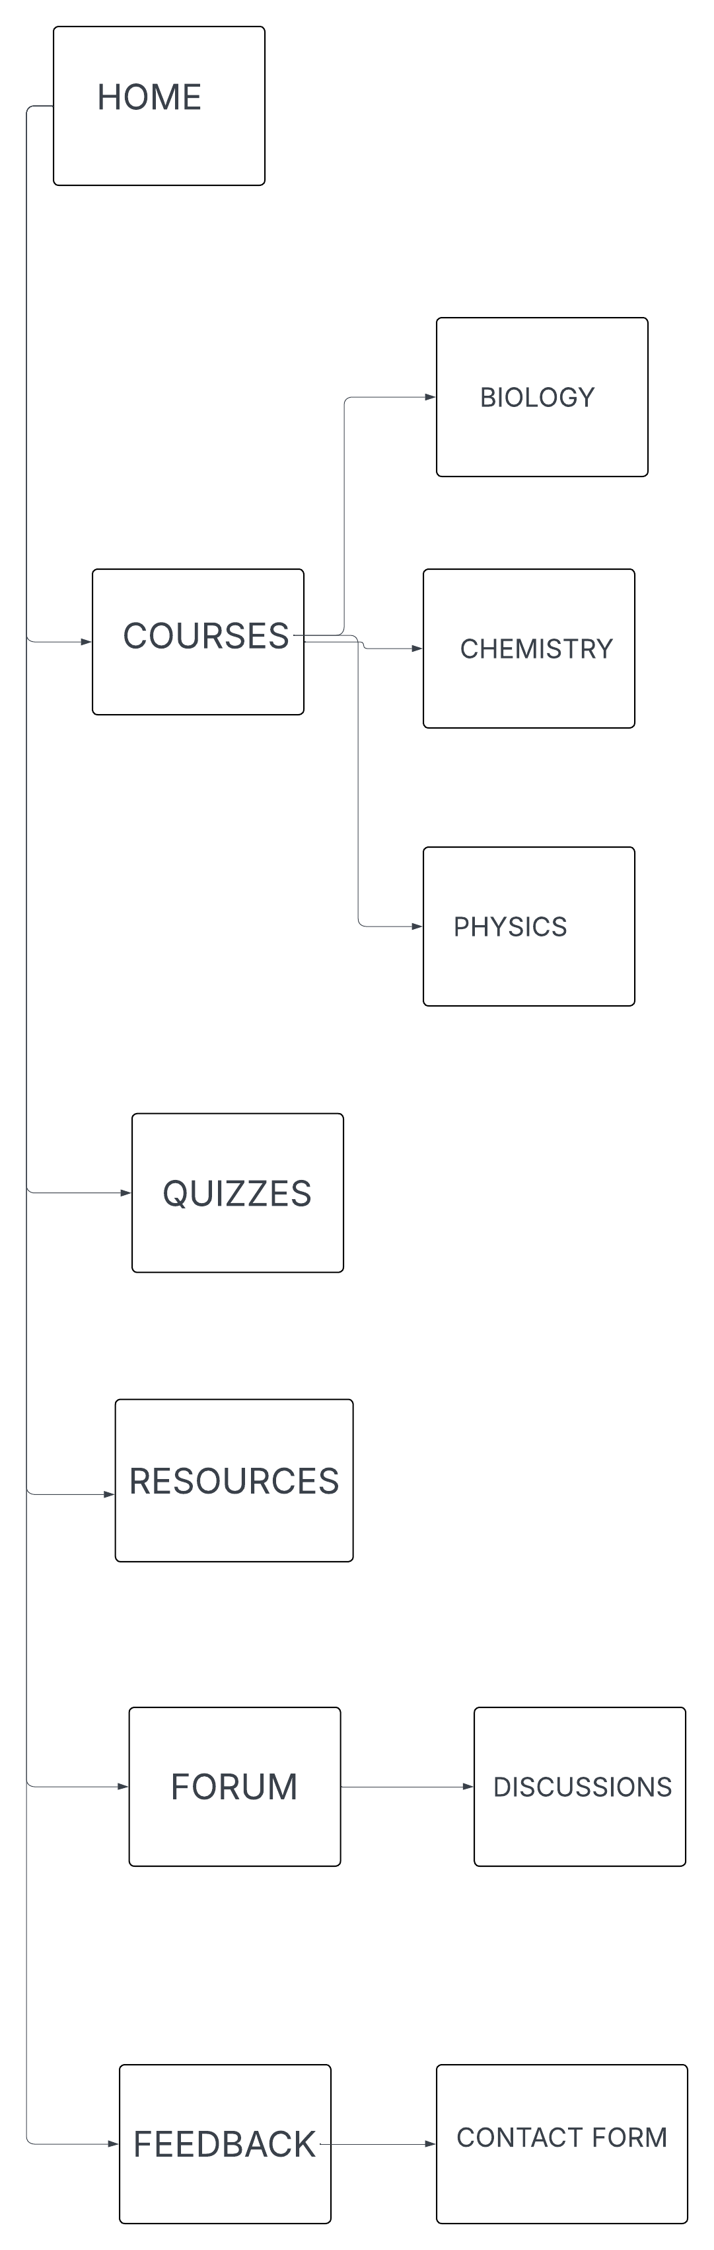

Navigation Paths
- Users start at the Home page
- From Home, they can navigate to any main section using the menu bar
- Within courses, users can select a subject and view lessons
- After learning, students can go to Quizzes to test their understanding.
- Users can access Resources anytime for extra materials
- Users can visit the forum to ask questions or share ideas
- Users can provide comments on the quality of the website, report issues, and suggest improvements using the Feedback section.
Storyboard flowchart
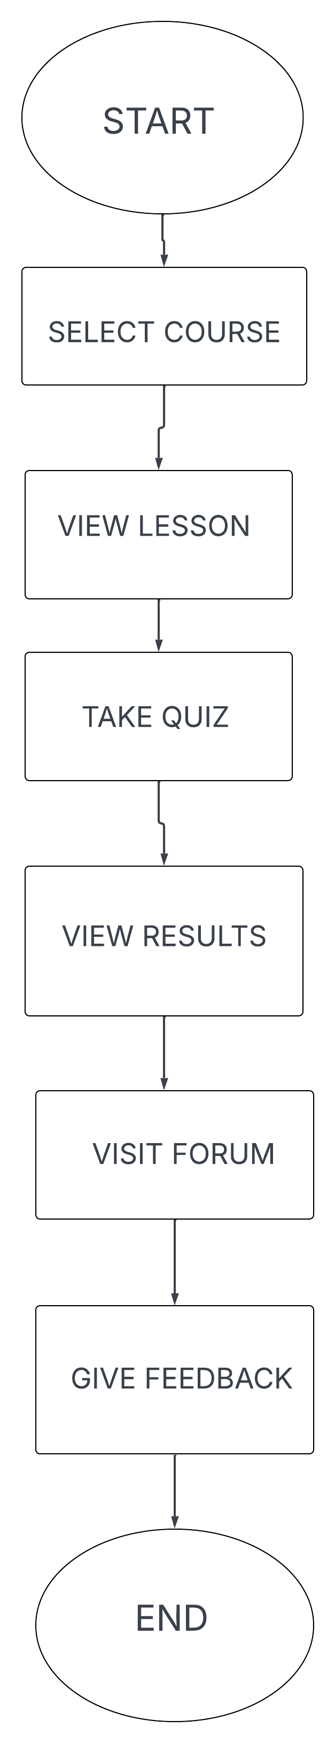

Technical Brief
This website will be developed using tools that are of its level of complexity.
Technologies Used:
- HTML-used to structure the web pages.
- CSS- used to style and design the layout.
- JavaScript- used to add interactivity (quizzes, forum posts)
Software Tools
- Visual Studio Code( VS code)- for writing and editing code
- Web Browsers- for testing the website
- GitHub- for version control and hosting the website.
Graphics Tools
- GIMP- for designing images, banners and logos
- Free online images- for visual enhancement

